LA-SHOP is a unique new shopping experience with 150 shops throughout the world. The shops are categorised into Europe, North America and Australasia regions.

LA-SHOP is essentially a department store, however they differentiate themselves from similar stores by the ‘experience’ they offer to the shopper. For example all stores have:
- A crèche and child activity centre where children can be left for up to three hours for a small charge;
- A personalised shopping facility, where the customer can discuss their requirements with the ‘store shopper’, the shopper will return with their shopping and/or options to discuss whilst the client waits in a private and comfortable lounge;
- In-store male and female hairdressing and beauty;
- In store café with free wi-fi access;

Additionally some stores offer:
- Interior design service;
- Bespoke tailoring service;
- Bespoke kitchen design.

The aim of LA-SHOP is to provide a ‘day out’ experience for all the family. They record details of customers and use direct marketing to inform them of special promotions. Some of the facilities are provided by a ‘contractor’ known as the owner, LA-SHOP do not have access to these companies financial and management data.

LA-SHOP management are aware of the amount of data they are holding in the system and believe that this could be used to manage the business better.

To this end you have been called in to advise on how best to create a Data Warehouse with a management reporting OLAP system.

- Who are the stakeholders of LA Shop?
- Identify potential strategies, aims and objectives for LA Shop.
- Choose one of these strategies to further consider.
  - How could this been achieved? (come up with an idea to help improve/implement the strategy/aim).
  - What reports would help you evaluate the current situation and future situation. (ie evaluate the effectiveness of the implemtation)
  - What data is required for the report?
  - Draw out an example illustration of this report (maybe use excel).
- We will come together to discuss the nature of these reports and a data store to support these reports.

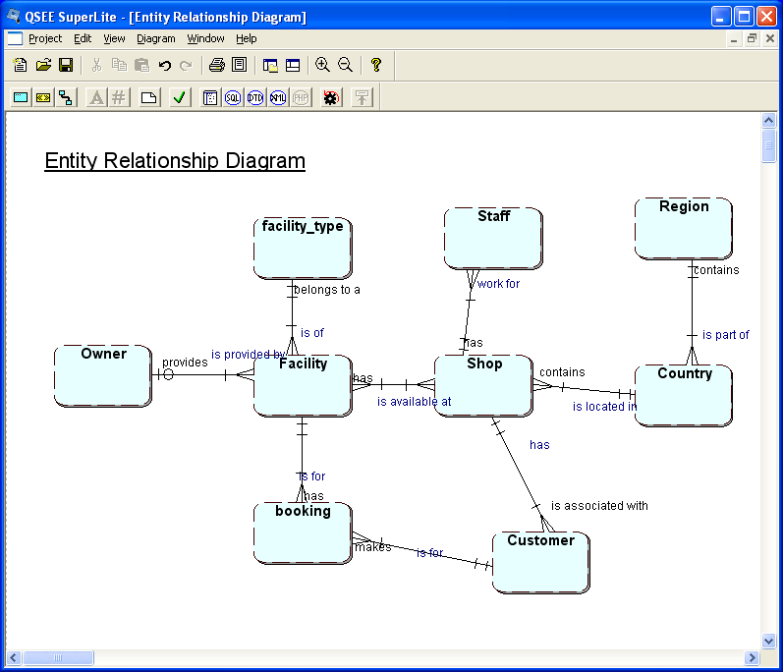

This is an example of the data model for one shopping mall

Data Analysis Exercise

Consider the data for the tables below:

Booking(booking_id, Customer_id, nursery_id, date_booked, booking_start_time, Booking_end_time, booked_by, no_in_party, special_notes)
Customer(Customer_id, customer_name, customer_address, customer_type)
Booking
1 | 100 | 70 | 01/01/2008 | 09:30 | 12:30 | null | 1 | own food provided
3 | 100 | 71 | 01/01/2010 | 10:00 | null | AB | 2 | doesn't know end time
5 | 101 | 72 | 02/01/2008 | 11:00 | 13:00 | AB | one
Customer
100 | Alan Abbots | 1 Ascot Ave | A
101 | Ben Bloggs | 2 Blue Boulevard | A
103 | Charlie Chaplin | 3 Cool Crescent | New

What are the problems, anomalies, issues with the data above ?
Make a suggestion as to how to address each case.

